I. The Dilemma Every Musician Faces—"What Style Truly Suits Me?"
In the early stages of music creation, many artists find themselves stuck on a seemingly simple but incredibly time-consuming decision: style positioning. When a musical motif pops into your head, or you write a line of lyrics that touches your soul, should those words be wrapped in a wall of sound built by distorted guitars, or laid out gently with a solitary grand piano?
To achieve the best results, creators often have to experiment with different arrangements for the same material. However, the cost of traditional style-building is far too high for fleeting inspiration. In professional Digital Audio Workstations (DAWs) like Cubase, testing a single style requires loading various virtual instruments, programming corresponding MIDI drum grooves, and even adjusting the frequency distribution of the entire mix. By the time you’ve spent hours building a rock framework only to realize it weakens the delicate intimacy of the lyrics, the frustration of starting over can often kill your inspiration entirely.
What creators truly need isn’t to fall into the trap of technical details right away, but rather a "Virtual Audition Room" where ideas can be instantly visualized. In this room, the cost of switching genres should approach zero. In this article, we’ll explore MakeBestMusic, a cutting-edge AI music production tool.
II. Using MakeBestMusic: "How to Quickly Find Your Own Musical Style?"
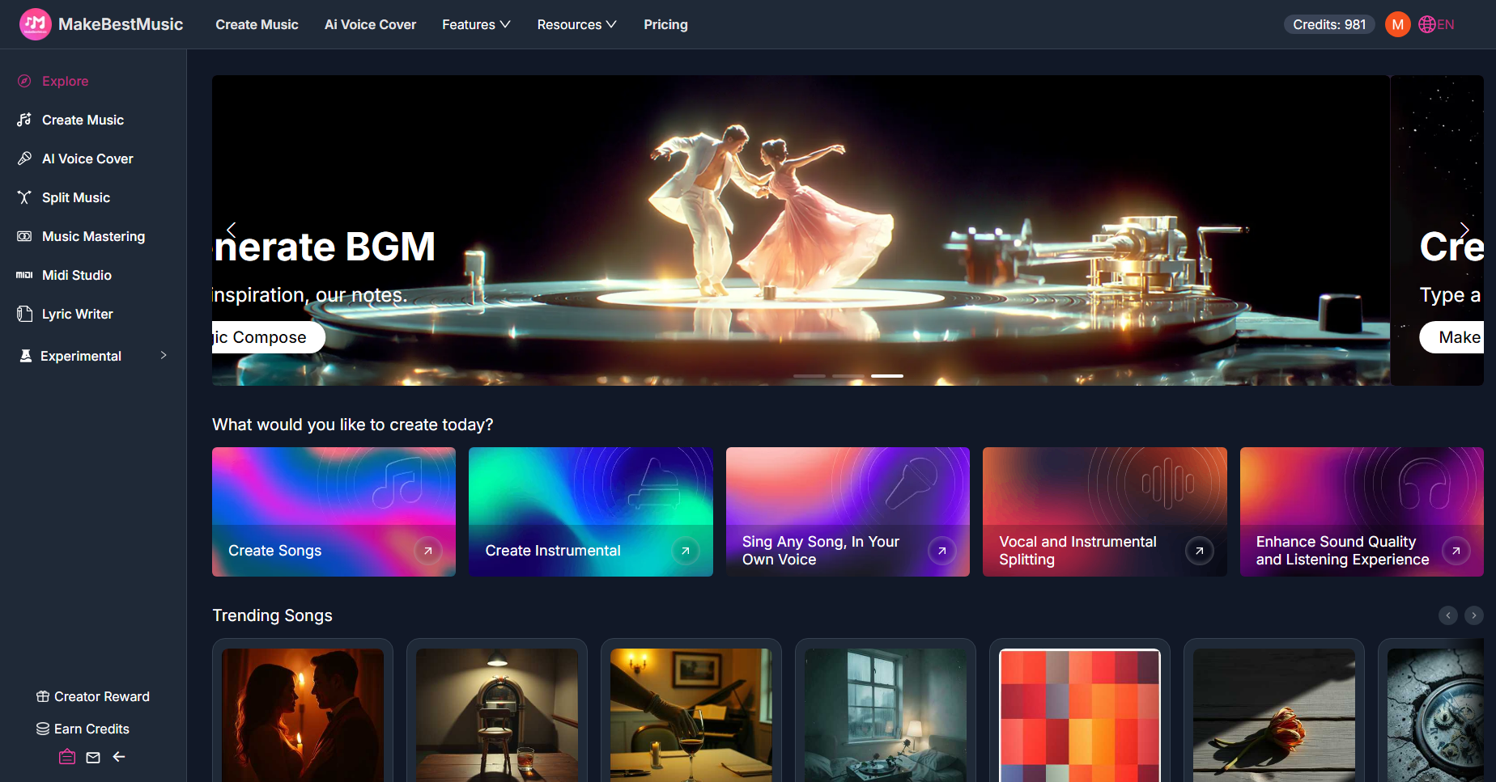
In music production, the choice of style is often more decisive than the melody itself. It serves as the emotional container for the work—the same few lines of lyrics represent rebellion in a Rock setting, yet feel like liberation in Jazz. This choice is difficult because, in traditional workflows, it is impossible to pre-visualize complex orchestration effects in your head. Once a direction is chosen and the arrangement begins, the cost of turning back is immense.
The emergence of MakeBestMusic (MBM) reconstructs this decision-making process from the ground up. Its AI core deeply understands the emotional nuances of text commands and precisely transforms them into complex orchestration. You no longer need to be an expert in the physical characteristics of every instrument; you simply give "Director's Commands" through scene descriptions, and the AI instantly mobilizes its massive acoustic database for "real-time orchestration."
This text-to-music capability allows you to move the same musical motif horizontally across different styles at an extremely low cost. To help you intuitively understand the importance of this feature, we have selected three representative musical directions to see how MakeBestMusic gives the same melody entirely different lives through distinct orchestration logic.

Style 1: Rock — For creators who want to tell intense, story-driven tales
If you want your work to have a strong sense of momentum, or if your lyrics are full of internal conflict and emotional outbursts, Rock is the natural vessel. When processing Rock commands, MakeBestMusic’s AI model automatically calls upon dynamic kick drum samples, heavy electric guitar distortion, and high-energy live-sounding basslines. This style gives lyrics a raw, unpolished power, perfect for musical expressions that need to directly stimulate the listener's senses and tell a dramatic story.
Style 2: Pop — For creators chasing "catchiness" and wider reach
When you prioritize melodic hooks and want your work to have the potential to go viral on social media or streaming platforms, Pop is the safest bet. MakeBestMusic-generated Pop music typically follows strict commercial mixing standards: vocals are placed at the absolute center of the mix, while the accompaniment features bright electronic synths, crisp acoustic guitars, and upbeat drum patterns. It filters out acoustic elements that are too extreme for the general public, delivering information in a smooth, accessible way—the top choice for recording daily emotions and mainstream expression.
Style 3: Jazz — For creators building atmospheres for premium scenarios
If your goal is to build a specific spatial atmosphere—such as background music for a late-night podcast, a cafe, or a high-end brand video—the complex harmonic systems of Jazz can instantly elevate the quality of the product. When analyzing Jazz styles, the system utilizes syncopated rhythms and configures saxophones, double bass, and warm-toned pianos. This style strips away aggressive emotions, serving creative scenarios that require sophistication and relaxation through a lazy, spacious vibe.
III. Switch Styles in 30 Seconds: A Step-by-Step Guide to Generating Songs in These Three Styles with MakeBestMusic
Having understood the core of these styles, let’s move into practical operation. As a powerful song generator, MakeBestMusic can achieve style conversion for you simply by entering commands. Open the MakeBestMusic web console, and we will demonstrate how to validate different musical styles in 30 seconds using a standardized workflow and a core prompt template.
After entering the homepage, click on the "Create Music" module to enter the workstation. Toggle the "Custom" mode switch. Once activated, locate the "Lyrics" text box and paste your lyrics. Below the lyrics, you will find the "Style of Music" input box. To ensure the AI generates a complete song with professional transitions rather than a monotonous, blurry loop, you can use structured long prompts here. Here are three style prompt templates to serve as your reference for writing prompts:
Rock Style Prompt Example:
An Alternative Rock anthem with a strong narrative arc in 4/4 time.
[Intro]
opens with a gritty, clean electric guitar melody and subtle room reverb, setting a reflective, moody atmosphere.

[Verse 1]
introduces a steady, driving bass line and light percussion, keeping the focus on the raw storytelling vocals.

[Pre-Chorus]
builds intense tension with rapid snare rolls and a gradual increase in guitar distortion and volume.

[Chorus]
reaches a powerful climax with heavy power chords, crashing cymbals, and a soaring, high-energy anthemic melody.

[Outro]
fades out with lingering guitar feedback and a final, resonant floor tom hit for a dramatic ending.
Pop Style Prompt Example:
A Modern Synth-Pop song tailored for commercial radio in 4/4 time.

[Intro]
features bright, shimmering synth pads and a catchy 4-beat electronic pulse.

[Verse 1]
combines a clean, rhythmic acoustic guitar with a soft sub-bass to keep the focus on the vocals.

[Pre-Chorus]
introduces rising white noise sweeps to build anticipation.

[Chorus]
delivers an explosive earworm melody with thick synth layers, a driving dance beat, and polished vocal harmonies.

[Outro]
concludes with a stripped-back version of the main hook and a clean digital cut-off.

Jazz Style Prompt Example:
A sophisticated Lounge Jazz piece with a late-night, smoky atmosphere in 4/4 swing time.

[Intro]
sets a mellow mood with a solo brushed snare and a warm, rhythmic upright bass line.

[Verse 1]
adds an intimate grand piano melody featuring rich harmonic colors and soft, improvisational flourishes.

[Pre-Chorus]
introduces a subtle, muted brass section to add warmth and harmonic depth to the arrangement.

[Chorus]
features a soulful, smooth saxophone lead playing over a steady walking bass line and elegant piano accompaniment, creating a sense of luxury and space.

[Outro]
concludes gracefully with a final sustained piano chord and a single, distant,t lingering upright bass pluck.
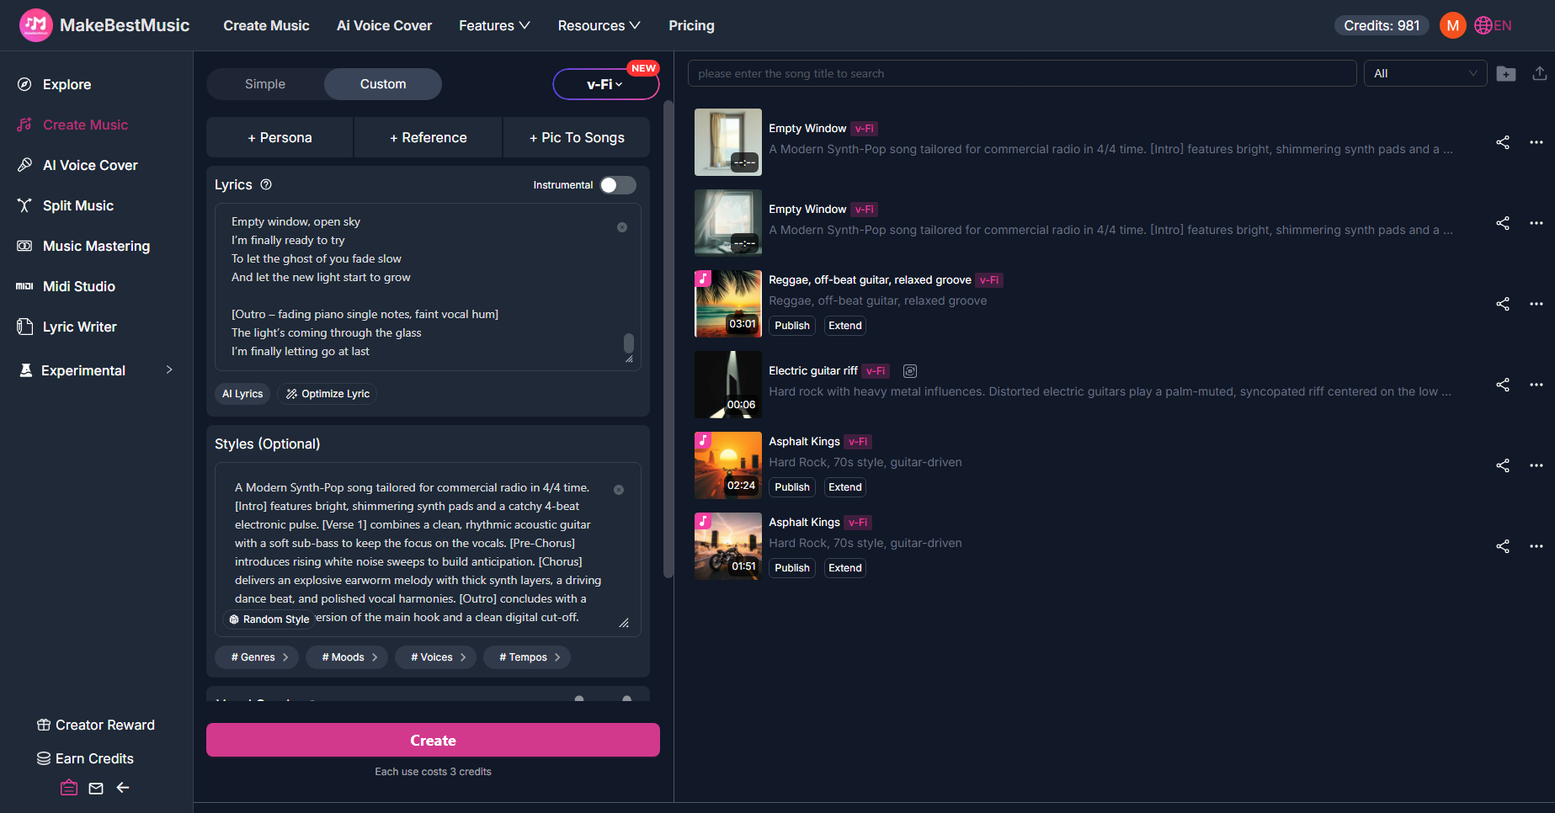
You don’t need to reinvent the prompt structure every time. To switch to Rock or Jazz, simply take this template, replace the style definition in the first sentence, and modify the instrumentation and emotional descriptors for the corresponding sections.
For example, if you want to hear the Rock version of your song, simply change the first sentence to "Alternative Rock with a strong narrative arc," replace the "acoustic guitar" in [Verse 1] with "steady bass and light percussion," and replace the synths in the [Chorus] with "heavy power chords and crashing cymbals." For Jazz, switch to "Sophisticated Lounge Jazz" with "grand piano, saxophone, walking bass."
After checking that the parameters are correct (check the "Instrumental" option if you don't need vocals), click the "Create" button at the bottom. Processing usually takes a few dozen seconds. Once finished, the audio will appear in the history list on the right. Click play and compare these versions side-by-side; your ears will instantly tell you which one fits your inspiration.
FAQ
1、What if I have a melodic inspiration but can’t write lyrics that fit the style?
Many producers have great musical sense but struggle with lyrical concepts. MakeBestMusic can solve this: return to the Custom mode interface and find the “Generate Lyrics” button. Enter your core imagery or story summary (e.g., "A long drive at dusk") in the window. The system will automatically generate lyrics containing structural tags like [Verse] and [Chorus]. This physical layout is not only clear and easy to read but also creates perfect synchronization with your structured style prompts, guiding the AI singer to shift emotions at the right moments and eliminating the disconnect between music and vocal structure.
2、How do I change the generated song’s vocals to my own voice to strengthen my style?
Songs generated by MakeBestMusic use system voices by default, but you can use the AI Singing Generator module to give your track a "Lead Singer" of your choice. In the top navigation bar, find and enter the "Voice Cover" interface. Step one: drag a clean,n dry vocal stem into the upload area. This clip should ideally be between 1 and 60 seconds, without any background reverb or accompaniment noise. Then, select the generated track you are satisfied with from the list below. The model will deeply learn the pronunciation habits and resonance characteristics of your uploaded dry vocals and overlay them seamlessly onto the generated track. This means you can use your own voice to perfectly perform a high-difficulty rock vocal piece, all within a single browser page.
3、Who owns the copyright to the generated music? Can I use it to monetize YouTube videos?
MakeBestMusic has clear definitions for commercial licensing. If you are using a Pro or higher-level paid plan, you own perpetual commercial rights to all audio generated through the platform. You can use it as background music for personal media, release it on Spotify to earn streaming royalties, or integrate it into commercial advertising projects without facing Copyright Claims from the platform.

4、How do I keep the tracks for music that already has a distinct style?
To accommodate the post-production workflow of professional creators, MakeBestMusic provides the "Split Music" function. Find your work in the history records and click the menu to execute separation. The system uses algorithms to deconstruct the song into independent dry tracks (usually including independent vocals, drums, bass, and melodic instruments). You can download these high-quality stems directly into your arrangement software to re-engineer EQs or add your preferred reverb plugins. MakeBestMusic will truly become a qualified assistant for your pre-production material.
Summary
Through MakeBestMusic's clear interface logic and powerful text generation capabilities, whether you're testing the impact of a rock arrangement or seeking a balance between pop and jazz, answers that used to take days can now be found in 30 seconds with a structured prompt. Once you master a powerful AI music tool like MakeBestMusic, the next thing holding you back won't be "choosing a style," but how much inspiration you have waiting to be released. Log in to MakeBestMusic now and see which style makes your inspiration shine brightest.

